Assignment 7 : Docker
one repo -- three branches -- master, 2026Q1, 2026Q2 -- all three have index.html files in them
JM -- use jenkins declarative pipeline—
create three containers c1 – master, c2 - Q1, c3 - Q2
bind c1 - 80
bind c2 - 90
bind c3 – 8080
Using Bind mount

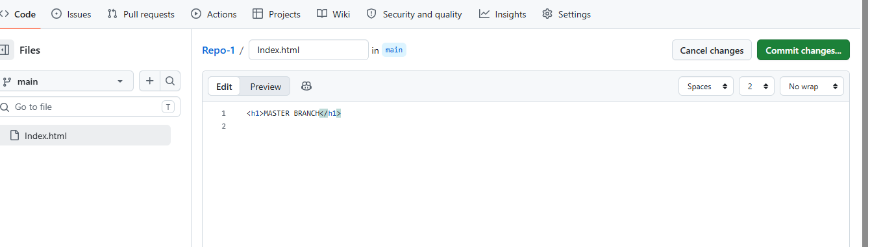

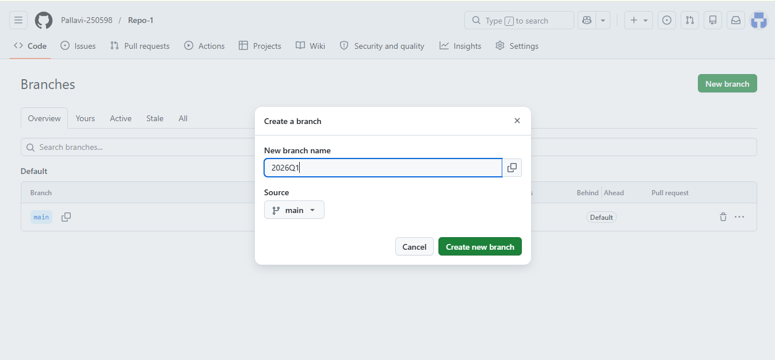

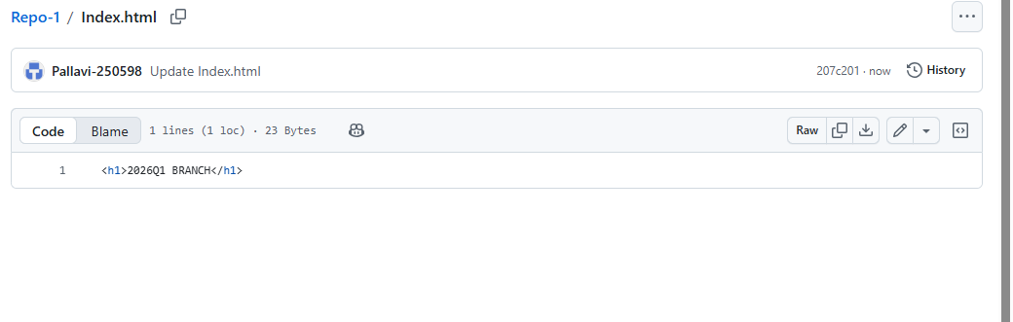
Install Jenkins in this server
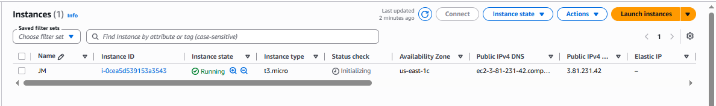

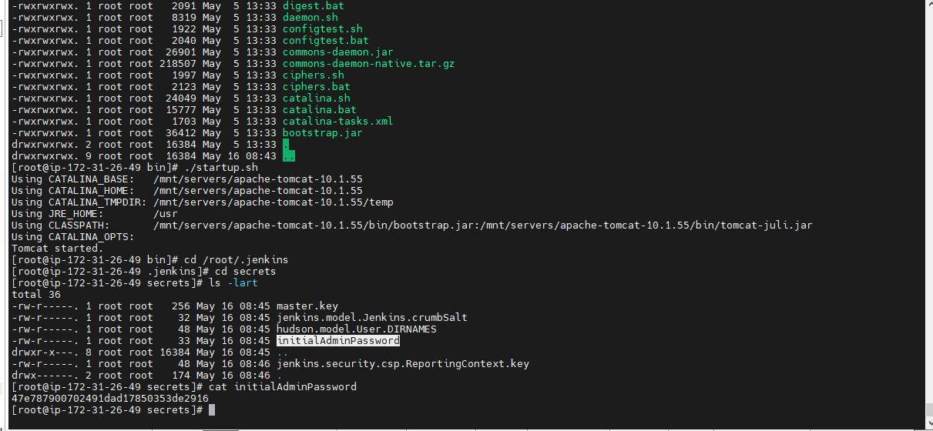

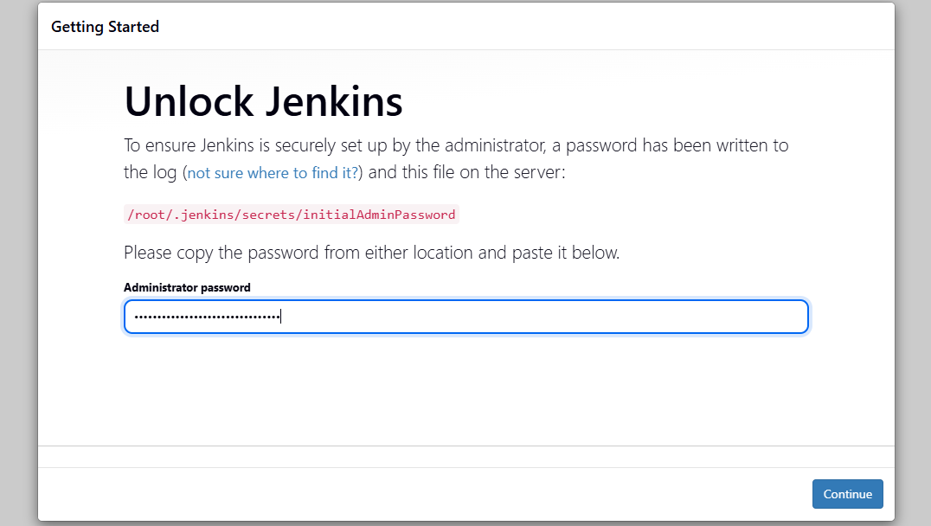

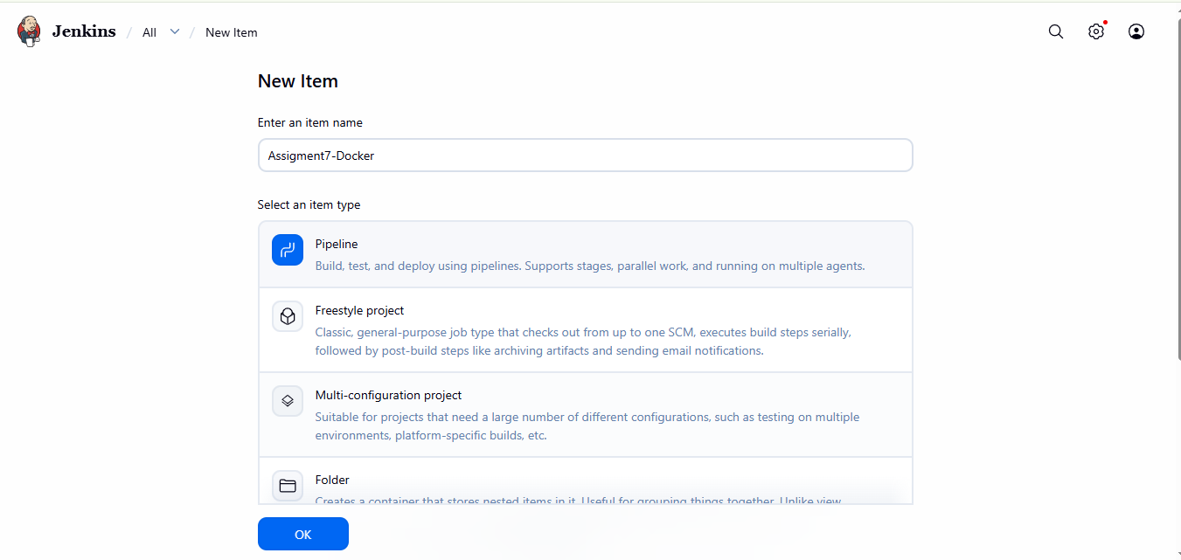

Run Jenkins job :

Container will be visible in server:
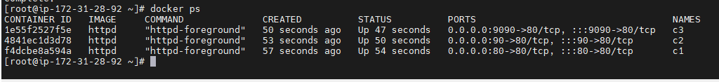
Try to access index file :
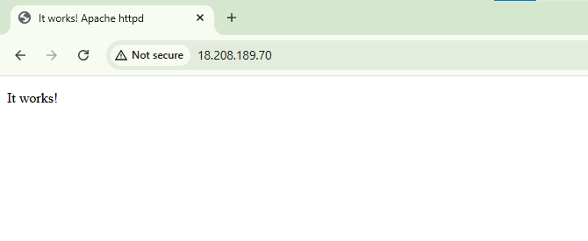

Main branch

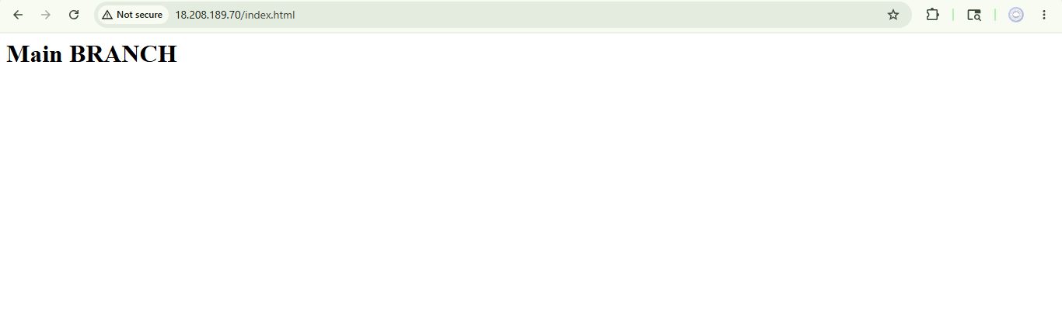

pipeline {
agent any

stages {

stage('Deploy MAIN to C1') {
steps {
sh '''
docker rm -f c1 || true

git clone -b main https://github.com/Pallavi-250598/Repo-1.git repo

docker run -dit --name c1 -p 8081:80 httpd

docker cp repo/index.html c1:/usr/local/apache2/htdocs/index.html
'''
}
}

stage('Deploy Q1 to C2') {
steps {
sh '''
docker rm -f c2 || true

git clone -b 2026Q1 https://github.com/Pallavi-250598/Repo-1.git repo

docker run -dit --name c2 -p 8082:80 httpd

docker cp repo/index.html c2:/usr/local/apache2/htdocs/index.html
'''
}
}

stage('Deploy Q2 to C3') {
steps {
sh '''
docker rm -f c3 || true

git clone -b 2026Q2 https://github.com/Pallavi-250598/Repo-1.git repo

docker run -dit --name c3 -p 8083:80 httpd

docker cp repo/index.html c3:/usr/local/apache2/htdocs/index.html
'''
}
}
}
}

